

SOFTWARE DESIGN SPECIFICATION
Happy Programming

I. Software Design Document

1.1 Package 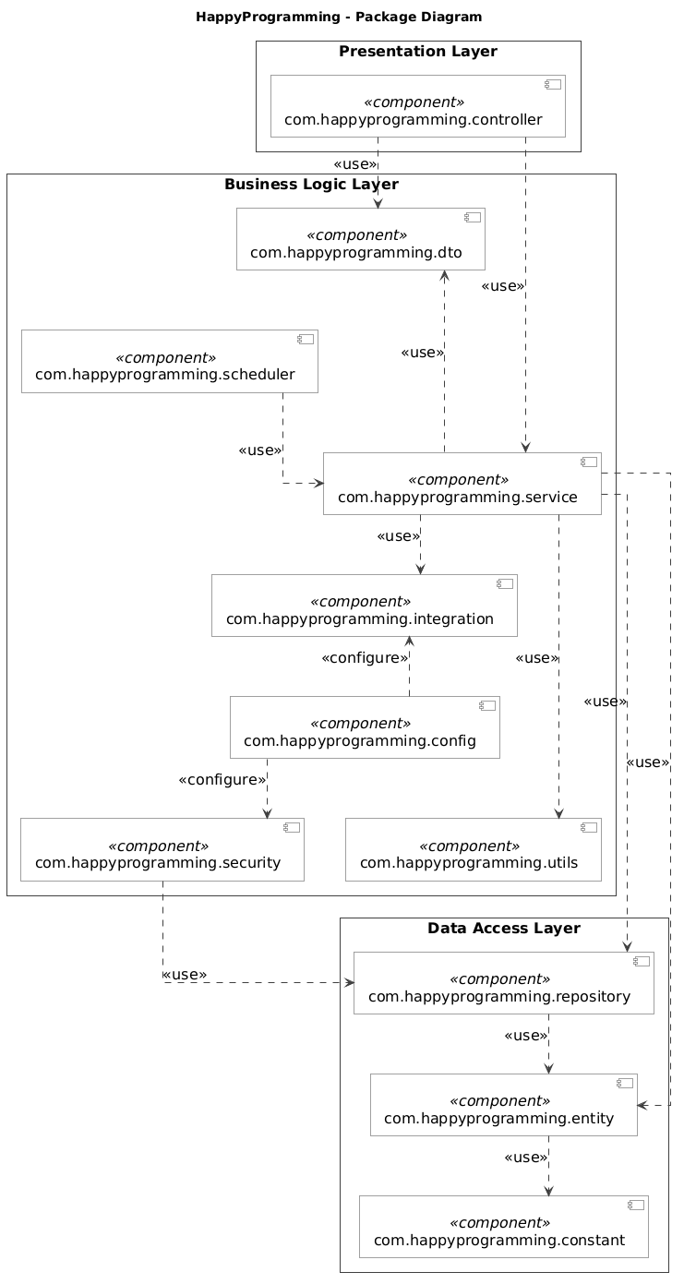Diagra

No | Package | Description
01 | com.happyprogramming.config | Contains application configurations, including SQL Server connections, Spring beans, security settings, WebSocket setup, and external service configurations.
02 | com.happyprogramming.constant | Stores shared constants and enumerations, including user roles, Staff permissions, mentorship request statuses, booking statuses, and payment statuses, to avoid hardcoding across the application.
03 | com.happyprogramming.controller | Handles HTTP requests for authentication, mentor discovery, mentorship applications, bookings, payments, reviews, and administration. Validates request data and delegates business processing to the service layer.
04 | com.happyprogramming.dto | Contains Data Transfer Objects for exchanging request and response data between layers. Supports input validation and prevents sensitive entity fields from being exposed to clients.
05 | com.happyprogramming.entity | Contains JPA entities mapped to SQL Server database tables, including users, mentor profiles, mentorship requests, subscriptions, bookings, payments, messages, and reviews. Defines persistent fields and relationships between entities.
06 | com.happyprogramming.repository | Contains Spring Data JPA repository interfaces and custom queries for retrieving, creating, updating, and deleting persistent data. Supports pagination and locking where required.
07 | com.happyprogramming.service | Implements core business logic for mentor approval, mentorship applications, scheduling, subscriptions, payments, escrow accounting, messaging, and reviews. Coordinates transactions and ensures monthly mentorship is activated only after mentor acceptance and verified payment.
08 | com.happyprogramming.security | Handles authentication and authorization using Spring Security, including Google OAuth2 login, password hashing, role-based access control, individual Staff permissions, and resource ownership checks.
09 | com.happyprogramming.integration | Provides adapters for external services, including VNPay payment and refund processing, Google Calendar/Meet session creation, and Gmail email delivery. Handles external requests, responses, and integration errors.
10 | com.happyprogramming.scheduler | Contains scheduled tasks for expiring unanswered mentorship requests, pending payments, and temporary slot holds, as well as processing subscription lifecycle changes and permitted log cleanup. Calls service methods to execute business rules.
11 | com.happyprogramming.utils | Provides reusable helper classes for date and time conversion, data formatting, reference generation, and other common operations used throughout the application.

